**PROJECT 2**

**Store management System**

**The main screen has Add product Add Customer Add purchase Manage Product**

**Manage Customer Manage Purchase**

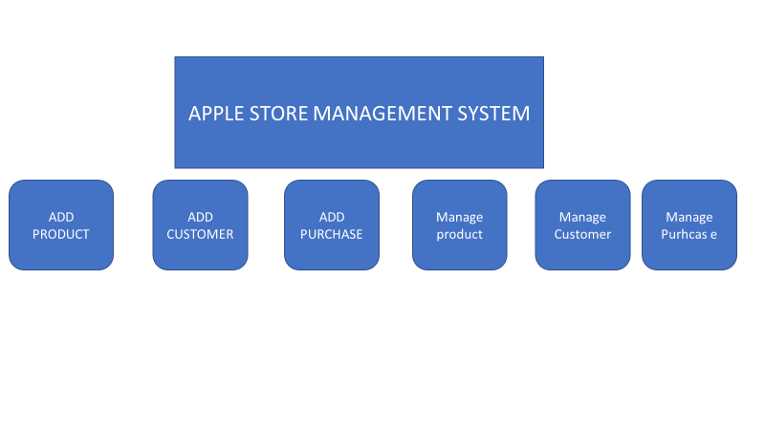

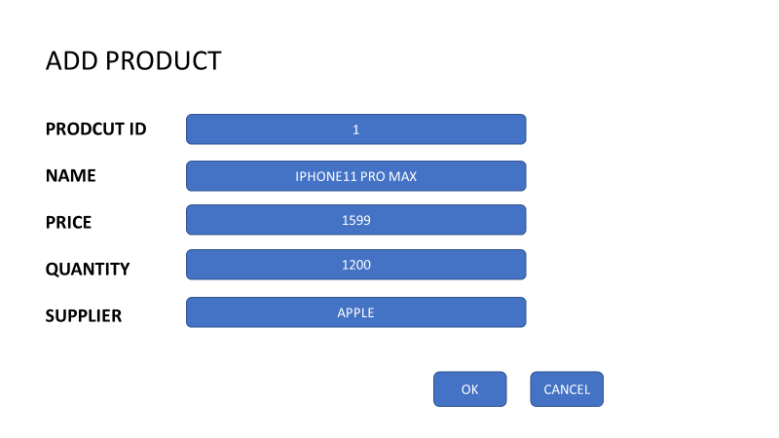**new product is added and ok screen is prompted**

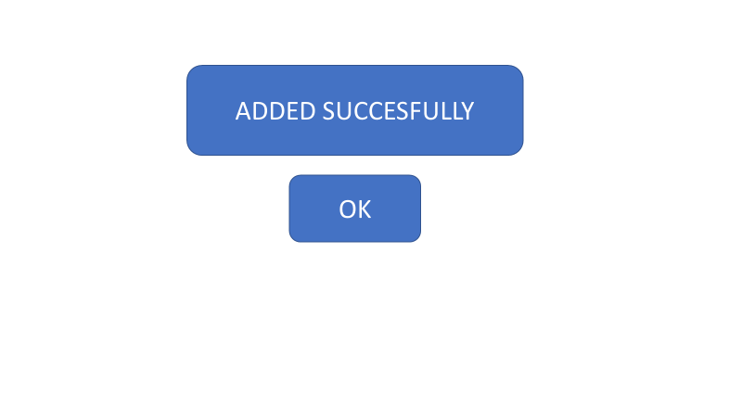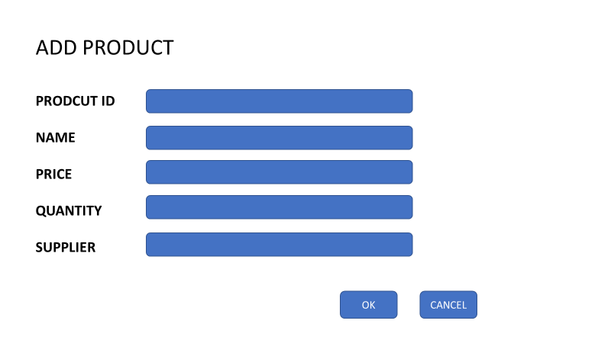

**Update Product UI**

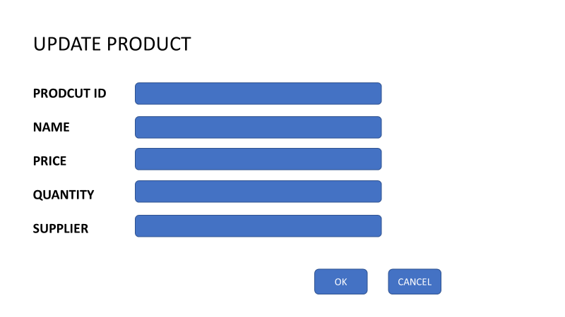

**Missing field generates error.**

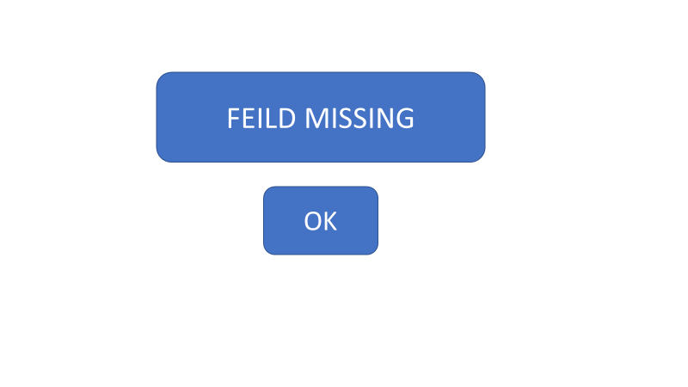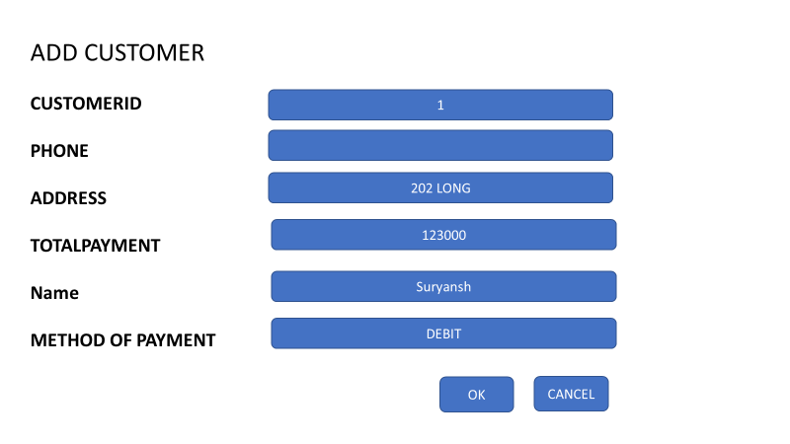

**new Customer is added and ok screen is prompted**

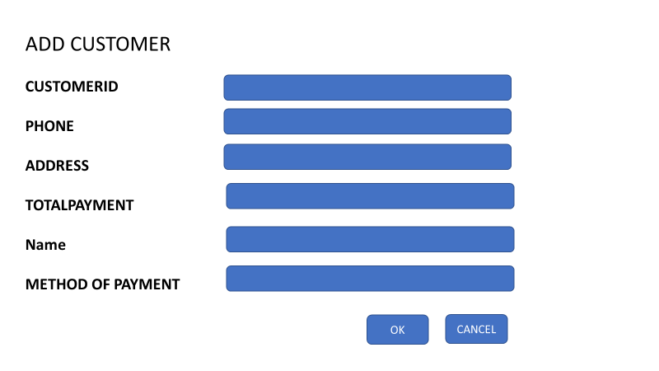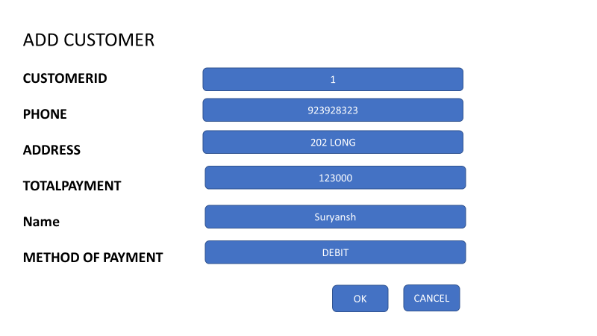



**Update Customer** 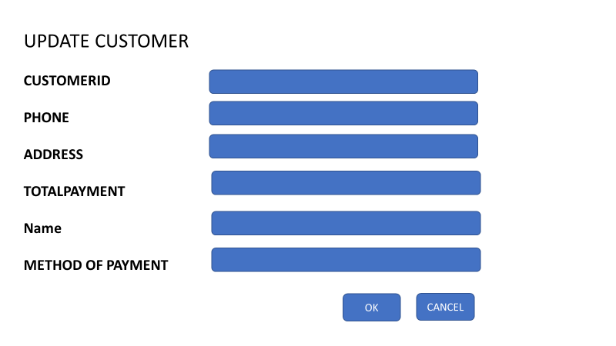

**Missing field generates error.**

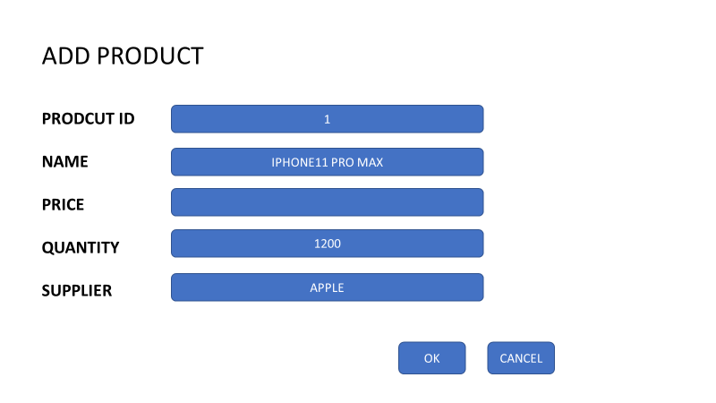

**new purchase is added and ok screen is prompted**

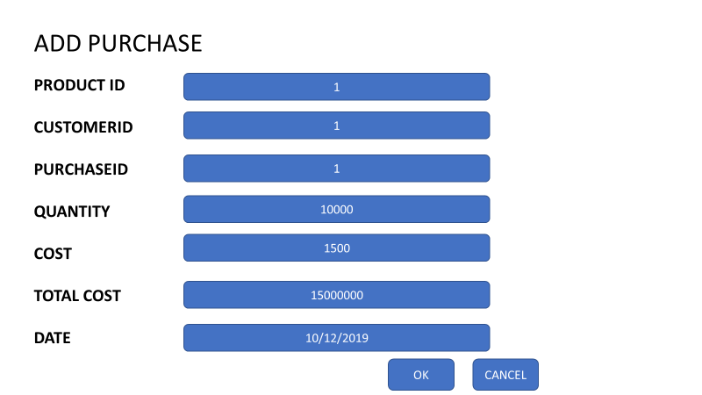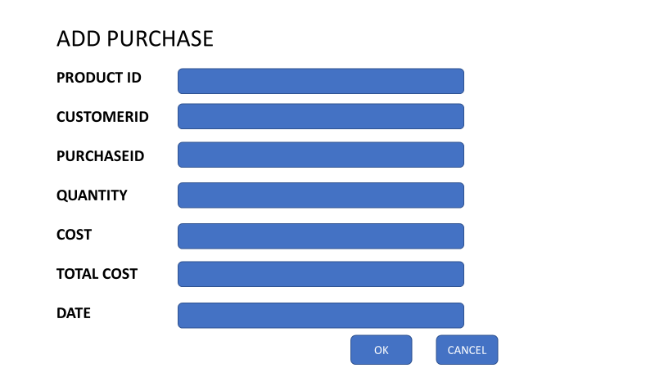



**Update Purchase**

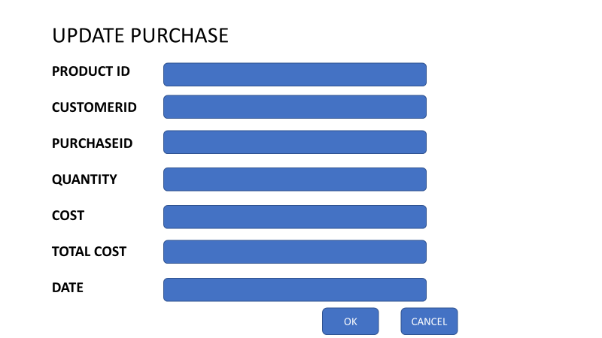

**Missing field generates error.**

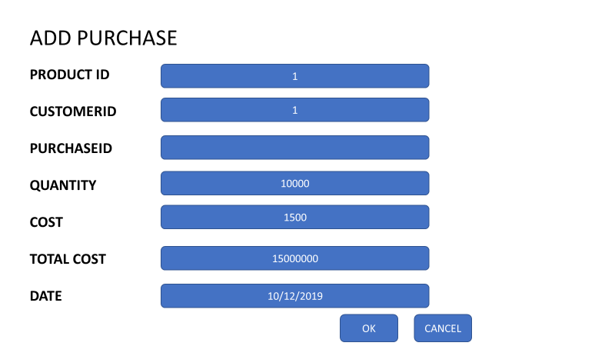

**Main UI**

**Add purchase Add customer Add Product**

**Update Purchase**

**Update Product**

**Update Customer**

Story

- As a user, I want to add a new product or update a current product in the system.

User cases

* Correct id is supplied which load the values of product

|  |  |
| --- | --- |
| When user enters a input in user Id which exist   | Server connects to database  Prompts the other values of name ,price ,quantity  ,vendor name   |
|  | Server passes the new value in database and Values gets changed in database   |

* All correct values supplied by user and product is saved

* Invalid value supplied result in error

- As a user, I want to add a new customer or update a current customer in the system.

* Correct id is supplied which load the values of Customer

|  |  |
| --- | --- |
| When user enters a input in user Id which exist | Server connects to database  Prompts the other values for the following fields |
| when user changes the current values to something new value | Server passes the new value in database and Values gets changed in database |

* All correct values supplied by user and Customer is saved

* Invalid value supplied result in error

- As a user, I want to add a new purchase or update a current purchase in the system

* Correct id is supplied which load the values of purchase

* Correct values are supplied by the user and the values are saved

New purchase can also be added using manage purchase option

* Invalid value supplied result in error

OLD DATA VALUES

NEW UPDATED DATA VALUES

